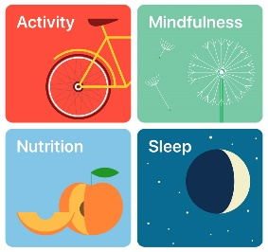
Health Fair
Advocating for Health
and Well-Being

Big Idea: Advocating for health and well-being of others connects us to our community.
Purpose: To research the importance of health and wellness, advocate for your passion and positively influence your peers.
Who: Groups of 2-3
Keywords: Food/nutrition, fitness, wellness, relationships

Topics for Inquiry:
- Effects of different types of physical activity on the body
- Healthy sexual decision making
- Consequences of bullying, stereotyping, and discrimination
- Physical, emotional, and social aspects of psychoactive substance use and addictive behaviours
- Influences of physical, emotional, and social changes on identifies and relationships
- Importance of nutrition, sleep, and exercise

Questions for Inquiry:
- What is your health topic? Why is it important to your and to your peers? (Provide detailed information)
- How do we advocate and promote health and well-being?
- What are the short and long term consequences of healthy decisions related to your topic? (ex. nutrition, protection from STIs, sleep routine)
- What is some relevant information regarding your topic?
- How can you present strategies for others to protect themselves from: potential abuse, exploitation, harm in a variety of settings, medical issues related to your topic
- What are strategies we can implement your healthy living choice into our daily lives? What is the short and long term plan?

You Will Need:
- Strong and reliable sources of health information (professional documents, health and fitness magazines, professional websites)
- To investigate your topic and provide clear information on what it is and why it is important
- Propose healthy choices that support lifelong health and well-being for self and others

Your Booth Will Have:
- What you are advocating for and why? Why is this important to you and your peers?
- What should your peers know about this topic?
- How can they implement this information into their own lives/understanding?
- Provide examples/resources (something peers can take away)

What You Will Hand In:
- ALL research pertaining to your health topic
- A WRITTEN reflection (500 words)
  - Why is this health topic important to you?
  - What did your learn from your research?
  - How did you share and advocate for your health topic?
  - How are you going to plan for better health and wellness?
  - How do you intend to positively influence others to do the same?
  - Any other thoughts.

***Detach and return to Mr. Veeken

Health Topic:______________________________________________________________

Group Members:______________________________
________________________________
________________________________

