Analyzing Fiber Intake Parts 1 & 2 Lab: 24 pt Part 3: 10 points possible
Food Science

Purpose:
Fiber is an essential part of a healthy diet, yet many Americans lack the recommended amount required for our bodies to function properly. Many consider granola as a high fiber food, yet granola ingredients can vary. In this lab, you will determine if this particular recipe is high in fiber using the MyFitnessPal program and analyze how the recipe could be improved.
Part 1: Finish the Recipe Ingredients
Choose up to 4 dried fruits for the following recipe. Potential items are included below but feel free to add others if you’d like. Note that there are a total of 8 T per ½ c so you can mix and match your fruit ratios as you’d like.

Incredible Granola Bars Yield: 4 servings
Recipe Source: "Incredible Granola Bars." Recipe. N.p., n.d. Web. 14 Nov. 2014. <http://www.food.com/recipe/incredible-granola-bars-361537>.
Ingredients:
¾ c rolled oats
¼ c flax seed
¼ c brown sugar
2 T canola, safflower, coconut, or avocado oil (record which type you choose)
2 T honey or agave syrup (record which type you choose)
½ t salt
2 T cocoa nibs or chocolate chips (record which type you choose)
½ c dried fruit (potential options: dried bananas, dried apples, craisins, raisins, dried cherries, dried mango or other of your choosing)
Original recipe calls for dried bananas but the combination of dried fruit used is your choice.
** Be sure to record the exact amount of each type of fruity you either used or would potentially use below:

Dried Fruits Chosen and Amounts (minimum 1 or up to 4 dried fruits): Note: 8 T = ½ c so combine as you’d like to get to the ½ c mark
_____________________________________________
_____________________________________________
_____________________________________________
_____________________________________________

Part 2: Prepare Recipe
Recipe Instructions:
- Preheat the oven to 350° F and spray an 8 x 4” bread pan with nonstick cooking spray. (see Note #1)
- Mix all of the ingredients thoroughly and press into the prepared pan.
- Bake for 20-25 minutes. If possible, allow it to cool before cutting into bars. (see Note #2)
Note #1: If you double the recipe, use a square cake pan.
Note #2: If not allowed to cool, the mixture will break like traditional granola. Use storage bags to take the final product with you.

If absent: Feel free to prepare these at home for you and your family. This is 100% optional (but tasty). Even if you do not prepare the recipe, be sure to complete Part 2 where you will analyze the recipe using the MyFitnessPal app.

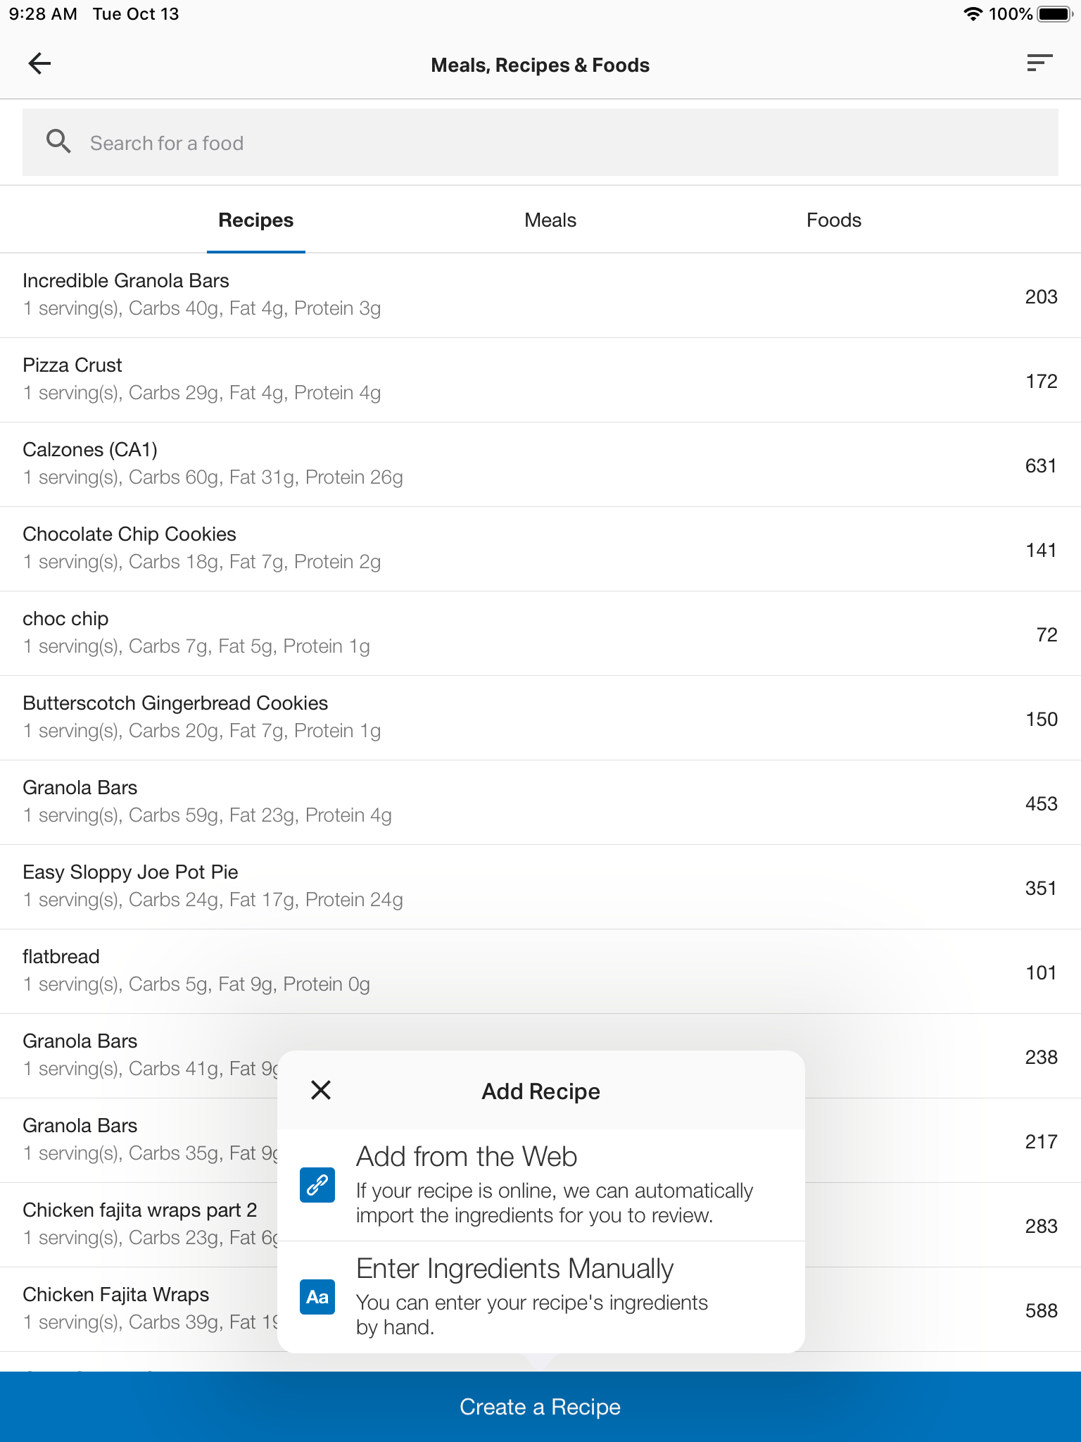
Part 3: Analyze the Recipe
Use the MyFitnessPal tutorial to create an account on either an iPad or Google Chromebook (if not done previously)
Explore the program to familiarize yourselves with its options.
Click this link for more tutorials on the app.

To add a recipe in the app:
- Click on the *** MORE icon in the lower right hand corner
- Click on My Meals, Recipes, & Foods →Create a Recipe
- Two options at add recipes to MyFitnessPal:
Note: You can add any recipe of choice from the web for your own use/reference to determine the nutrition facts of any recipe at any time. Don’t feel like you need to wait for any assignment to do this 😁
Option 1: Add from the web
  - For this assignment: copy and paste the link from the original recipe source:
https://www.food.com/recipe/incredible-granola-bars-361537
  - Once the site is loaded in the window, click on Import Recipe
  - Confirming Ingredients: Once your list of ingredients is imported from the web, tap the check mark in the top right of the screen.
  - You can then access the recipe’s nutrition in the My Meal, Recipes, & Foods and click on More Nutrition Facts to complete the chart below.

Option 2: Enter ingredients manually (linked to a third party article)

Complete the following chart using the Nutrition Facts for Incredible Granola Bars:

INCREDIBLE GRANOLA BARS NUTRITION FACTS | Total Calories | Total Carbohydrates | Dietary Fiber | Sugars
1 SERVING

Answer the following questions:
- Would you consider a serving of this recipe to be considered a low, moderate, or high source of fiber? Explain your rationale (use your Fiber Frenzy assignment for help in determining this answer). (2 pt)

- Research the ingredients found in this recipe for the following:
What ingredient(s) were beneficial to the recipe’s fiber intake? (2 pt)

- Research other high fiber foods:
Identify at least 3 ingredients you would be willing to add that would contribute to the recipe’s fiber content and still maintain a pleasing overall flavor. (2 pt)

